**Sound**

* Sound is a form of **mechanical energy** which produces the sensation of **hearing**.
* It is produced due to **vibrations** of different objects. It travels in the form of waves.

# Propagation of Sound

* A material medium is necessary for the propagation of sound. It can be solid, liquid or gas.
* The disturbance which moves through a medium when the particles of the medium set the neighbouring particles into motion is known as a **wave**.
* A sound wave can be considered the propagation of pressure or density variations in the medium, i.e. it propagates in a medium as a series of compressions and rarefactions.
* A region of compressed air (increased density or pressure) is called a **compression** (C) and that of rarefied air (decreased density or pressure) is called a **rarefaction** (R).
* A vibrating object produces a series of compressions and rarefactions in the medium.

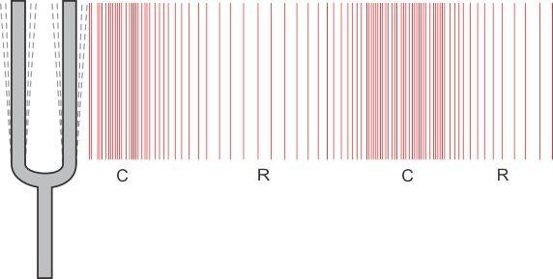

Example: When the prongs of a tuning fork move forward, compression is formed, and when the prongs move backwards, rarefaction is formed.

* As sound propagates, it is the sound energy which travels in the medium and not the particles of the medium.
* Sound waves are **longitudinal waves** as the particles of the medium through which the wave propagates vibrate in a direction parallel to the direction of propagation of waves.

# Variations in Pressure and Density of a Medium due to Sound Waves

* The variations of pressure and density when a sound wave moves in a medium are as shown below:

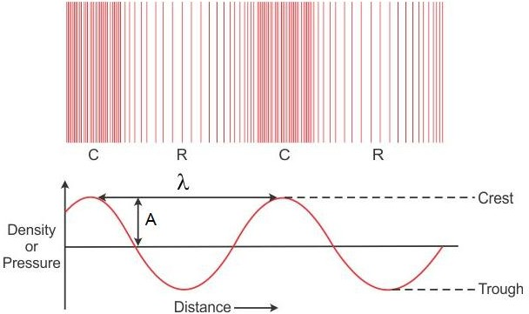

* The portion of the medium where density (or pressure) has a value larger than its average value is called a **crest**.
* The portion of the medium where density (or pressure) has a value smaller than its average value is called a **trough**.
* The magnitude of maximum disturbance in the medium on either side of the mean position is called the **amplitude** (A).
* When a sound propagates through a medium, the density of the medium oscillates between a maximum value and a minimum value.
* The change in density (or pressure) from the maximum value to the minimum value and again to the maximum value is called an **oscillation**.
* The number of complete oscillations per second is called the **frequency** ( ν ) of the sound wave. Its unit is **hertz** (Hz).
* The time taken for one complete oscillation in the density (or pressure) of the medium is called the

**time period** (T) of the wave.

* The distance between two consecutive compressions or two consecutive rarefactions is called

**wavelength** (λ) of the wave. Its SI unit is **metre** (m).

* Frequency ( ν ) and time period (T) are related as

■  1

T

* **Speed of sound** is the distance travelled by the sound wave per unit time.

Speed, v  Distance (λ)

Time (T)

* The relation between the speed of sound wave (v), its frequency () and wavelength ( λ ) is v = 

# Speed of Sound in Different Media

* Speed of sound is **finite** and is **much less than the speed of light**.
* Speed of sound in solids > speed of sound in liquids > speed of sound in gases
* The speed of sound increases with increase in **temperature**.

# Characteristics of Sound

* Sounds can be distinguished from each other by three characteristics—loudness (intensity), pitch (frequency) and quality (timbre).



Loudness

Characteristics of sound

Pitch

Quality

* The **intensity of sound** at any point is the amount of sound energy passing per unit time per unit area in a direction perpendicular to the area. Its unit is watt/metre2 (W/m2).
* The physiological response of the ear to the intensity of sound is called **loudness**. It is determined by the **amplitude** of the wave.
* **Pitch** is the physiological sensation which helps in distinguishing a shrill sound from a flat sound. It is determined by the **frequency** of the wave.
* **Quality (timbre)** distinguishes one sound from another sound of the same pitch and loudness. It is determined by the **wave form** of the sound.
* A sound of single frequency is called a **tone**.
* The sound produced by a mixture of several frequencies is called a **note**.

# Reflection of Sound

* The laws of reflection for sound are the same as those for light.
* The repetition of sound caused by reflection of sound waves from an obstacle is known as an **echo**.
* The time interval between the original sound and the reflected one must be at least 0.1 s for an echo to be heard distinctly.
* **Multiple echoes** are heard when sound is repeatedly reflected from several obstacles at suitable distances.
* The phenomenon of persistence or prolongation of audible sound after the source has stopped emitting it is called **reverberation**.

**Uses of Multiple Reflection of Sound**

* In megaphones, horns, musical instruments and stethoscopes, the mechanism of multiple reflection of sound is used.

# Range of Frequencies



Audible range

* 20 Hz to 20,000 Hz

Ultrasound

* Above 20 kHz

Infrasound

* Below 20 Hz

**Applications of Ultrasound**

* Ultrasound finds **applications** in industry, medical science and communication (SONAR).
* SONAR stands for **SOund Navigation And Ranging**. It is used to measure the distance, direction and speed of objects under the sea. It is also used in ship-to-ship communication.

# Human Ear

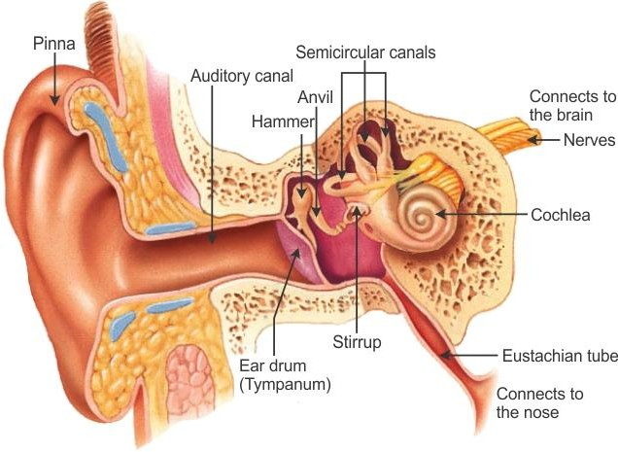

* The human ear can be divided into three parts:
  + The **outer ear** which collects the sound waves.
  + The **middle ear** which amplifies the sound waves about 60 times.
  + The **inner ear** which converts the amplified sound energy into electrical energy and conveys it to the brain as nerve impulses for interpretation.